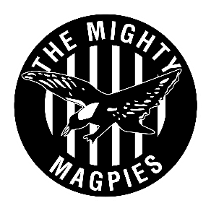
2023 PLAYER SPONSORS
PLAYERS SPONSORSHIP PROGRAM

Ask your employer, friend or family member who owns a business to jump on board our Player Sponsorship Program by supporting you as a player in season 2023.

The Club is developing this program to help players with the financial cost to participate in local footy. Your Players fees and membership fees will be paid for.

In Return for sponsoring your player in 2023 you will receive-
- An introduction to the North Mandurah Football Club Corporate Network
- Exposure to our club members
- Satisfaction of supporting a not for profit community club
- Invitation to club social functions
- Tax deductable invoice
If you are interested in being a Player 2023 sponsor please contact Rob Ireland nmfcpresident@hotmail.com

Male Player Sponsor $500
Female Sponsor $500
Players Name:
Business Name:
Business Address:
Contact Person Name:
Signature:
Email:
Phone:

